**2.1 ML for healthcare: Where are we on the Pathway to Personalisation**

Dr Dianelle Belgrave, DeepMind

* Heterogeneity
  + May affect individual’s responses
* Axes of impact in AI for healthcare
  + Research
    - Scientific discovery
    - ML and healthcare research
    - ML to solve particular problem
  + Practice
    - Human-centered solutions
    - Human interaction to ML
  + Innovation
    - Real-World impact
    - Interdisciplinary
  + Grand challenge:
    - Translating research insights into actionable impacts
* Overview
  + ML for Healthcare at DeepMind
  + Discovery: Understanding heterogeneity as a pathway towards personalisation
  + Practice: Decision Support Tools for real-world impact
  + Innovation: Moving forward on the path towards personalisation
    - Fairness
    - Should be embedded in ML/AI healthcare application
* DeepMind
  + Solving intelligence to advance science and benefit humanity
  + Health @ DeepMind:
    - Part of DL team
    - Health portfolio
    - Two aspects:
      * Advancing science
      * Benefiting humanity
* Machine learning for Healthcare
  + Data types:
    - EHR
    - Imaging
    - Omics
    - Multimodal data
  + Generalize heterogeneity and provide fair AI models
  + Aim:
    - Scientific discovery: Understanding disease mechanisms for early detection and prevention
    - Disease treatment: predict health outcomes, and enable preventative, personalized care
    - Reinventing the future of health: Creating fairer AI for healthcare
* Machine Learning in Healthcare
  + ML techniques

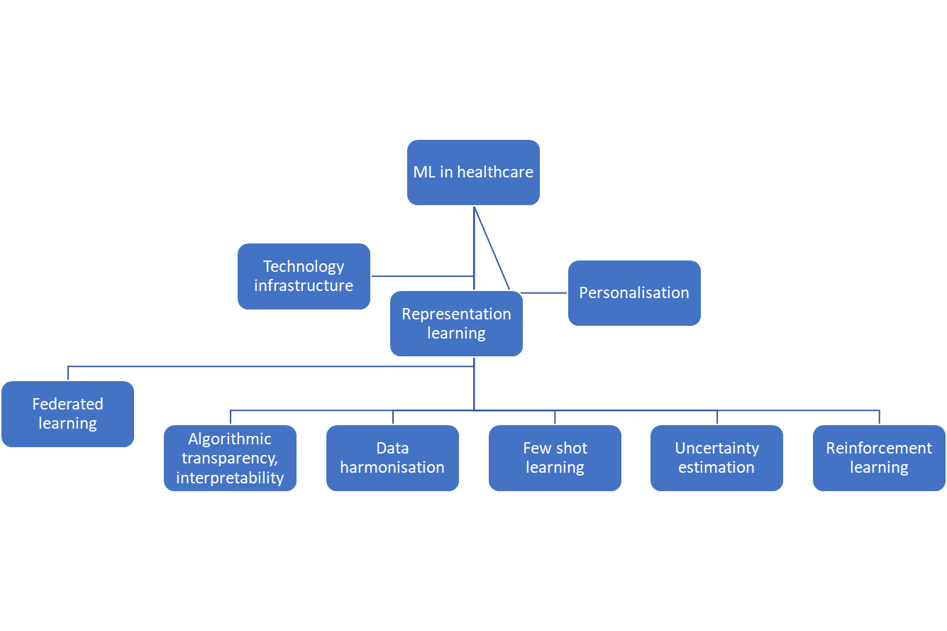

* Healthcare modality
  + Imaging: MRI, Ultrasound
  + EHR: lab test results, clinical notes, ICU measurement
  + Omics: transcriptomics, metabolomics, genomics
  + Multimodal data: wearables, sensor data

**Discovery: Understanding heterogeneity as a pathway towards personalisation**

* Combine domain expertise + causality (heuristic approach) + ML (imitation, DL, ) -> personalisation
* Not one size fits all:
  + Generalisability:
    - Disaggregate complex phenotype understanding causal mechanisms
    - Leads to better personalisation strategies
  + A deep understanding of patient heterogeneity can lead to better generalisability
  + Important step toward creating fairer ML for healthcare models and systems
* Healthcare grand challenge
  + Heterogeneity over treatment response and conditions manifest at time
  + Trade-off between risk reward benefits
  + I.e.
    - Patients: same diagnosis and same prescription – potential outcomes;
      * Drug not toxic and beneficial
      * Drug toxic but NOT beneficial
      * Drug toxic but beneficial
      * Drug NOT toxic and NOT beneficial
* Identifying disease endotypes
  + Endotypes: probabilistic latent variable frameworks
    - Natural history of condition sof time based on phenotypes/ different symptoms
    - Can we learn parsimonious descriptions of data in data
  + Aim: to obtain parsimonious description of data (endotype) inferred from what is observed (phenotypes)
* Probabilistic programming
  + Latent variable: inferred
    - Commonly used in psychiatry
    - Based on some clinical features/ questions
    - <https://www.manning.com/books/practical-probabilistic-programming>

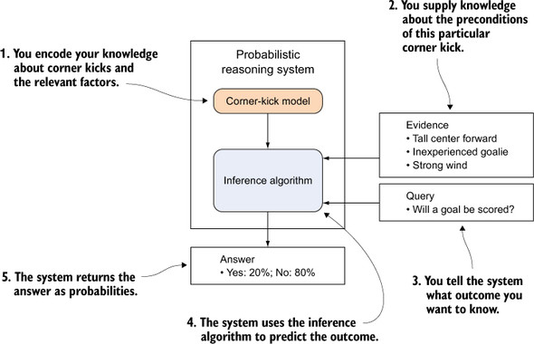

* + E.g. Causal mechanisms of asthma and allergy
    - <https://www.jacionline.org/article/S0091-6749(10)01858-0/fulltext>
    - Understanding the underlying mechanisms, better explaining clinical manifestation
    - Heterogeneity in response to treatment of asthma, eczema, and rhinitis
      * Progression of allergy: eczema -> asthma -> rhinitis
      * 12,000 children at different locations
    - 3 HMM:
      * <https://research-information.bris.ac.uk/ws/portalfiles/portal/103820045/1_s2.0_S0091674916313458_main.pdf>
      * Independent conditions
      * Allergic march
      * Independent conditions across time
        + Best model
        + Structural independence over time and over condition
    - Combination of symptoms and not mutually exclusive
      * Development profiles are heterogenous
      * Allergic March

**Practice:**

* Decision Tools on the Path to Personalisation
  + Clinical decision support tools can act as early-warning systems for more optimal personalised interventions
  + Personalised predictive models can help to define individual risk of AE
  + Important step towards creating fairer ML for Healthcare Models and systems
* EHR and AKI
* AKI: sudden drop in kidney function and creatinine in blood
  + Associated with poor outcomes
  + AKI problems before 2009:
    - <https://www.ncepod.org.uk/2009aki.html>
    - Delays in recognition
    - Poor management once recognized
    - Delays in access to specialist care
  + National Patient Safety Alert;
    - <https://www.england.nhs.uk/akiprogramme/aki-algorithm/>
    - Diagnostic AKI algorithm
    - Flagging AKI at clinical records
    - Population of national registry of AKI patients
* Continuous prediction of acute kidney injury (Nature 2019)
  + <https://www.nature.com/articles/s41586-019-1390-1>
  + RNN for continuous prediction of AKI up to 48 hrs using EHR data
  + End-to-end training with 7 auxiliary tasks (electrolyte lab values)
  + State-of-art performance and calibration
    - Prediction of 55.8% of all inpatient episodes of AKI
    - 90.2% of all AKIs that required subsequent dialysis
    - Ratio of 2 FPs for every true alert
  + Generalisability experiments showing model fairly robust to site/time
  + Limitation:
    - Sig. no of false positive
    - Demographically skewed
    - Ground truth label was not perfect
    - Not yet prospectively validate
* Feature representation
  + No imputation of missing values
  + 460k presence features encode missingness
  + 160k numerical feature normalized to unit range after capping at 1st and 99th percentiles
  + Age and time of day provided to model
  + Provide median yearly Cr baseline + min 48h baseline
  + Diagnosis pushed to end of admission to avoid information leakage
  + Aggregations of recent values included for baseline models
* Regularisation
  + L1 regularization on first layer of embedding module
  + Multi-task
    - Multiple windows for AKI
    - Multiple windows for each lab auxiliary task
  + Different adjustment
    - Dropout
    - Autoencoders/ VAEs
    - L2 throughout
  + RNN outperforms non-RNN models
    - By ROC AUC
    - Predict AKI 24hrs before admission
  + LImitation:
    - False positive reads for 1 to 2
      * Acceptable by clinical experts
* With different stages of AKI, model still with outperforms than actual task
* Example success case:

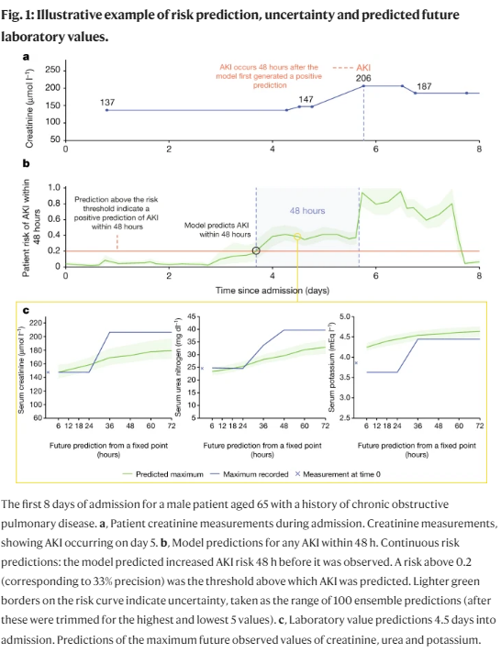

* False positive rates:
  + 49%
  + AKIs that go on requiring dialysis: 90%
  + Impact on workflow
  + False positive: most had events later on
  + Maybe a good intuition of later deterioration of kidney function
* Personalisation and Generalisability
  + **Use of deep learning to develop continuous-risk models for adverse event prediction from electronic health records**
    - <https://www.nature.com/articles/s41596-021-00513-5>
    - Utility of the pipeline across a number of different endpoints
    - Utility of pipeline on additional/different clinical data
    - Original models generalized well across time and hospital
    - Inconsistencies in feature representations meant it wasn’t possible to generalize across EHR system boundaries
  + **Multitask prediction of organ dysfunction in the intensive care unit using sequential subnetwork routing** 
    - <https://academic.oup.com/jamia/article/28/9/1936/6307184>
    - MTL has shown promise in improving model performance and training efficiency
      * Still suffers from negative transfer
    - Sequential subnetwork routing (SNR)
      * Soft parameter sharing to find related tasks and encouraging cross-learning
    - Improvements in label efficiency

**Innovation: Moving forward on path to personalisation**

* Personalisation: part of a pipeline
  + Centered to causal modeling frameworks to determine risk
    - Data-driven approach to stratifying interventions
    - Data-driven approach to stratifying underlying causal mechanism
  + Hypothesis generating:
    - Modeling frameworks to disentangle heterogeneity
    - Robust study design
    - Domain expertise
  + Hypothesis testing
    - Basic science to understand biological mechanisms and plausibility
    - Develop mechanism-based actionable interventions
* Creating fair systems for personalisation
  + <https://informatics.bmj.com/content/27/3/e100237.long>

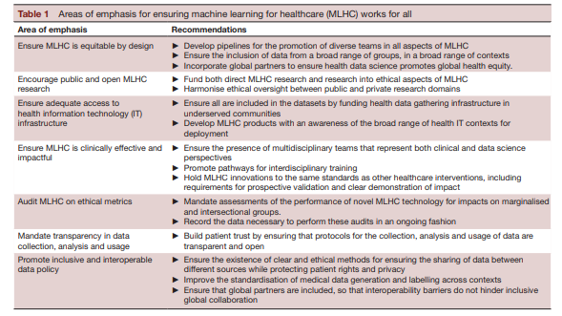

* Context matters
  + Solutions specific to problems
  + Merging different schools of thought for bigger picture
  + Data driven approach + Domain Knowledge = Problem-led approach with patient at the center